**Table of Content**

(Use CNTRL+F to skip to desired section)

1. GRE Tools and Materials
   * Textbook
   * Vocab Set
   * Pool Of Essay Topics
   * Online Guides
   * Free Practice Test
2. Disclaimer
3. Study Timeline
   * Score Progress
4. Math Notes
5. Verbal Notes
6. Essay 101

**GRE Tools and Materials**

**Textbook:**

*Manhattan Prep, 5lb book of GRE Practice Problems 2nd edition*

I bought a physical copy off amazon: <https://www.amazon.com/Lb-Book-GRE-Practice-Problems/dp/1937707296>

Or here’s a free pdf version: <http://booksdescr.org/item/index.php?md5=E061962A9E519C7ECAFA30CAF9584F55>

**Vocab Set:**

*Magoosh GRE vocabulary flashcards*

Download for your phone: <https://itunes.apple.com/us/app/gre-vocabulary-flashcards/id672962658?mt=8>

Or review online: <https://gre.magoosh.com/flashcards/vocabulary/decks>

**Pool of Essay Topics:**

Issues Essay: <https://www.ets.org/gre/revised_general/prepare/analytical_writing/issue/pool>

Argument Essay: <https://www.ets.org/gre/revised_general/prepare/analytical_writing/argument/pool>

**Online Guides:**

Reading Comprehension: <https://crunchprep.com/gre-reading-comprehension-guide>

Argument Essay: <https://www.kaptest.com/gre/gre-argument-essays>

Issues Essay: <https://www.kaptest.com/gre/gre-issue-essay>

**Free Practice Tests:**

<https://www.princetonreview.com/grad/gre-test-prep>

<https://www.kaptest.com/gre/free/gre-practice-test-options>

<https://www.manhattanprep.com/gre/free-gre-practice-test/>

<https://gre.crunchprep.com/test/start>

<https://www.ets.org/gre/revised_general/prepare/powerprep/?WT.ac=gre_36250_prepare_powerprep2>

**Disclaimer**

*As posted on Facebook:*

As a disclaimer I'd like to point out that while I was born in Japan, I was brought up in the United States. I graduated with a degree in Bio-psychology and a minor in Japanese. I also planned to minor in English. Additionally, I've been in the neuroscience field for 5 years, so I have a lot of experience reading scientific literature. I wanted to point this out because I understand that I have a huge advantage given my background and hope that many of you are not discouraged. That being said, I hope this helps you in your future endeavors.

*Additional notes about my study situation:*

I work full time (8-9 hours a day, 5 days a week, and sometimes a couple hours on the weekend) and have been preparing for this test for 3 months. I was very determined to only take this test once. This following timeline is roughly based on what I planned and does not reflect the breaks I took on some days, and even weeks on end. Please take this with a grain of salt and adjust to your situation and ability.

**Study Timeline**

1. Math

According to the *Manhattan 5lb GRE textbook*, the Math section is separated into 23 different sections. Not including most weekends, I did one section every night after work. This means it took me about a month and a half to cover this material.

1. Vocabulary

Based on the *Magoosh vocabulary app*, there are roughly 1000 words to memorize. The Magoosh vocab app has 20 ‘decks’ of vocabulary words that add up to ~1000. Depending on the difficulty, I made a goal to finish each deck in 3-7 days so I could finish before 3 months. I studied during lunch breaks, and every day before I went to bed.

Once I re-reviewed the vocab words I had difficulty on, which I did by making a vocabulary deck using <https://quizlet.com/latest>, I did the Text completion and Sentence Equivalence section of the *Manhattan 5lb GRE textbook* within one week.

According to my friend who obtained a PhD in material engineering, the benefit of learning more than 1000 words only becomes significant at 5000 words. Personally, I cannot learn 5000 words in 3 months. I would recommend you stay at 1000 and do a good job memorizing them.

1. Critical Reading

I did the Reading Comprehension and Logic Based Reading Comprehension from the *Manhattan 5lb GRE textbook,* over a period of 1 month. Not including weekends, I did around 20 questions each night after work AFTER I finished studying for my Math portion.

I read this: <https://crunchprep.com/gre-reading-comprehension-guide> 2 weeks before my test date and took it heart. Please see the Critical Reading section below for my notes.

1. Writing

I did 10 min practice sessions where I would practice coming up with my three argument points and type out the introductory paragraph. This was mostly to speed up my writing so I could finish before 30 min.

Here’s a calendar because it’s hard to explain:

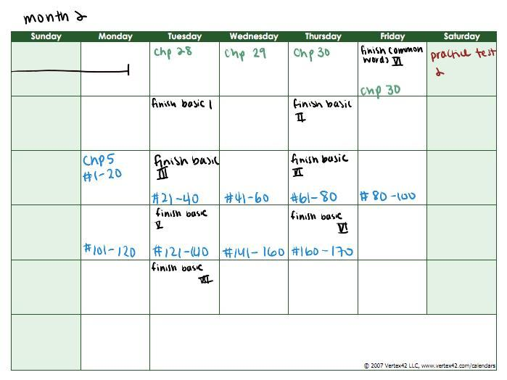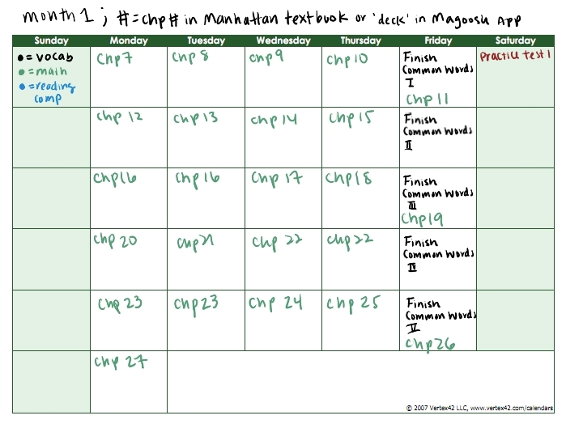

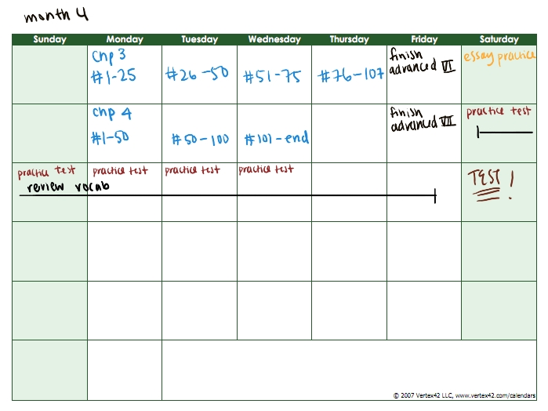



**Score Progress**

Test 1:

V - 157

Q – 153

Test 2:

V – 158

Q – 164

Final Test before Real Test:

V - 160

Q – 161

Test:

V - 161

Q – 165

**Progress**

V - +4 points

Q - +12 points

**MATH NOTES**

Besides memorizing specific rules and equations, every time you do a chapter, mark what you did wrong or right and DO NOT ignore the ones where you do not know HOW you got the right answer. Once you finish the section, and check your answers, go BACK and redo the all the questions that were wrong and all the questions that you didn’t know how to do.

Now, here are all the equations and rules that helped I wrote while I studied. It is not exhaustive (doesn’t cover everything)

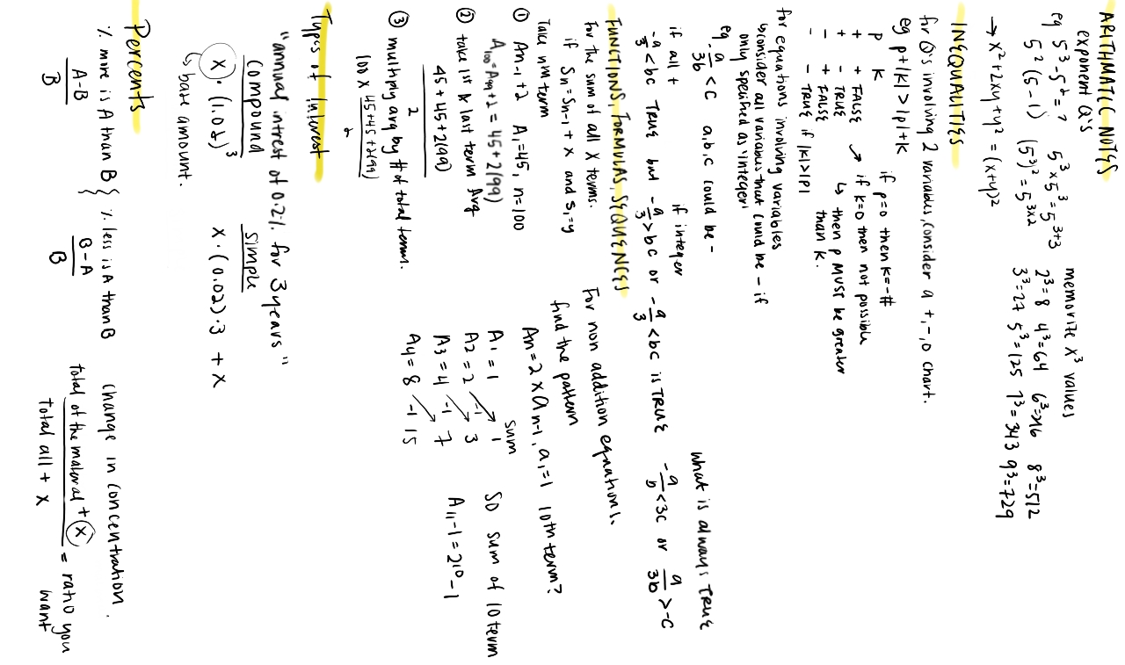

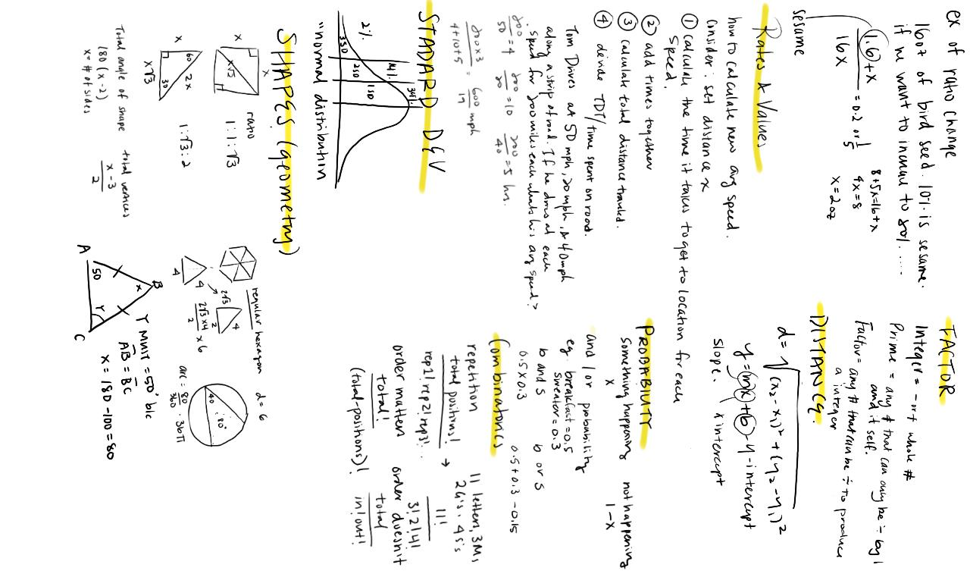

**Verbal Notes**

* Make lists of Vocab words that mean similar things, this will make memorization a lot faster
* Follow these notes: <https://crunchprep.com/gre-reading-comprehension-guide>

Quick Rules to Follow:

* Don’t’ choose extreme statements that utilize words like “only, all, every, always, never”
* Don’t choose answers with new info that is not from the passage
* Don’t choose distorted statements
* Don’t choose any assumptions
* Don’t choose any illogical, politically incorrect or outrageous statements

Things I found helpful from the Cruchprep doc:

* Take very quick notes (doesn’t matter if in English or your native language) which makes it easier to understand the passage. This will also save time so you don’t have to go back and read the entire passage when you answer difficult questions

**Essay 101**

Aka a shortened version of these documents: <https://www.ets.org/gre/revised_general/prepare/analytical_writing/issue/pool>

<https://www.ets.org/gre/revised_general/prepare/analytical_writing/argument/pool>

**Issues Essay:**

INTRO: restate the given issue. Write your thesis (write your position about the issue). Introduce reason/example 1, 2, 3 that will support your thesis.

Body 1: reason/example 1, should be your most specific reason with the strongest example

Body 2: reason/example 2, should be another example

Body 3: raise a counterargument which could weaken your thesis, and refute it with a third example.

CONCLUSION: restate topic. Restate position. Summarize three points with one sentence

**Argument Essay:**

INTRO: restate opinion. Summarize the evidence that they use. State their flaws and baseless assumption.

Body 1: lack of evidence

Body 2: weak evidence

Body 3: vague language

Body 4: point out what might be true, but give a specific suggestion to what could better the point

CONCLUSION: thesis restate. Talk about how the argument still needs work. Restate recommendations.